**BALDIVIS SECONDARY COLLEGE**

** Methods Units 1 and 2**

**2021 Test 2**

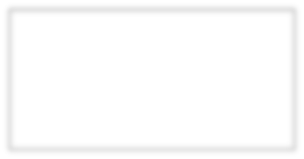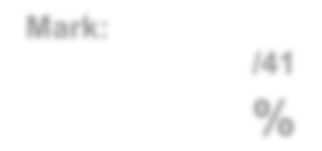

**Mark:**

**/34**

**%**

Student Name _____________________________________________

**Time allowed for this task:** 45 minutes, in-class, test conditions.

Section 1: 10 minutes + 2 minutes reading time

Section 2: 30 minutes + 3 minutes reading time

**Materials required:** **Section 1** Calculator free section (9 marks)

Standard writing equipment

SCSA Formula Sheet

**Section2** Calculator assumed section (25 marks)

Calculator (to be supplied by the student)

SCSA formula Sheet

One page A4 (double sided) unfolded

**Other materials allowed:** Drawing templates

**Marks available:** **34 marks**

**Task Weighting: 5%**

**Question 1 [2 marks]**

Convert these angles into degrees:

a) 



b) 



**Question 2 [3 marks]**

Express the following in radians:

a) 900 b) 1350 c) 2100



**Question 3**  **[2 marks]**

A pendulum AB has end A fixed and a weight attached at B. In one swing, the pendulum travels from B to C and back again (see diagram).

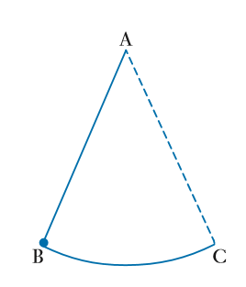

The pendulum is of length 80cm and ∠BAC = 0.9 radians.

How far does the pendulum travel in one swing?



**Question 4** **[2 marks]**

1. State the exact value of

­­­­­­­­­



1. Write down the exact values of



**END OF SECTION ONE**



**AEMAM Unit 1 – Test 2 – 2020**

**Name: Time allowed – 30 minutes**



**Calculator Assumed Section (1xA4 page of double sided notes, unfolded and approved**

**calculators. Formula sheet provided.) – 25 marks**

**Question 5 [8 marks – 4, 2, 2]**

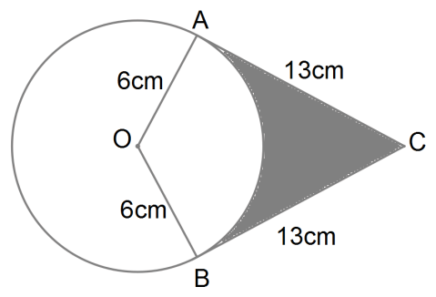Two tangents drawn from point B to a circle

with centre O and radius 6cm touch the circle



at the points A and C.



a) Find the size of angle AOC correct to 4 significant figures.



b) Find the perimeter of the shaded region.



c) Find the area of the shaded region.



**Question 6**  **[4 marks]**

The diagram shows a sector BAC of a circle with centre A and radius 16cm. Angle BAC is 0.8 radians. The length AD is 7cm. Calculate the area of region BDC

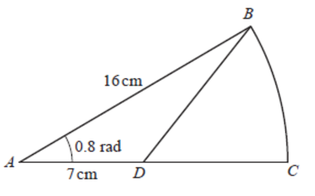

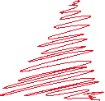

**Question 7** **[5 marks – 2, 1, 2]**

1. Determine the length of the minor arc GH.

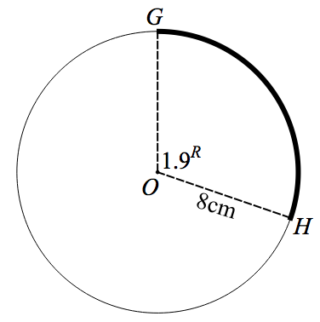



1. Determine the size of the angle in the major sector in degrees.



1. Determine the area of the minor segment GH.

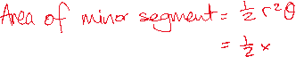

**Question 8 [8 marks – 2, 2, 2, 2]**

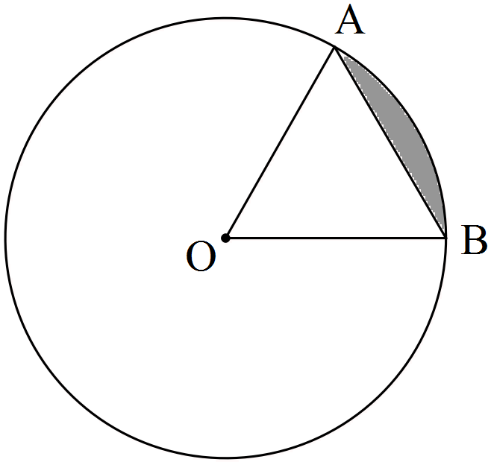

The circle shown with centre O has a radius of 3π cm.

If the size of ∠AOB = 60°, determine the

(a) area of triangle AOB as an **exact** value in terms of π.



(b) length of the ***major*** arc AB accurate to 2 decimal places.



(c) area of the ***minor*** sector AOB to the nearest cm2.



(d) area of the ***minor*** segment (shaded) formed by the chord AB accurate to 1 decimal place.



**END OF ASSESSMENT**